Multiple-choice section

|  |  |  |  |  |  |  |  |  |
| --- | --- | --- | --- | --- | --- | --- | --- | --- |
| Question | 1 | 2 | 3 | 4 | 5 | 6 | 7 | 8 |
| Answer | D | A | C | A | D | A | C | C |

Question 1 [5.1]

D





3*a* = 18

*a* = 6

Question 2 [5.2]

A

Let *x* be number of girls in the class*.*

If the number of boys is two-thirds that of the girls, then there are *x* boys in the class.

The total number of students is therefore *x* +*x*.

There are 20 students in the class, so *x* +*x* = 20, or 3*x* + 2*x* = 60

Question 3 [5.3]

C

Let *A*(*x*1, *y*1) = (-3, 3) and *B*(*x*2, *y*2) = (4, -2)

*x*1 = -3, *x*2 = 4, *y*1 = 3, *y*2 = -2

Write the distance formula, substitute in the relevant values, and evaluate.



Question 4 [5.4]

A

*a* increases by 2 and *b* decreases by 4, so the multiplying factor is -2. *b* = 4 when *a* = 0, so 4 will be the constant that is added after *a* is multiplied.

*b* = -2*a* + 4

Check by substituting a pair of values from the table.

When *a* = 2, *b* = -2 × 2 + 4 = 0

Question 5 [5.5]

D

*m* = 

= 

Consider the points (0, 1) and (3, -1).

Let *x*1 = 0, *x*2 = 3, *y*1 = 1, *y*2 = -1



Question 6 [5.6]

A

The gradient of the initial line is .

The gradient of the perpendicular line is the negative reciprocal of this: 

Question 7 [5.7]

C

3*x* − 2*y* = 12

When *y* = 0:

3*x* − (2 × 0) = 12

3*x* = 12

*x* = 4

∴ *x*-intercept = (4, 0)

Calculate the *y*-intercept by substituting *x* = 0 and solving the equation.

3*x* − 2*y* = 12

When *x* = 0

(3 × 0) − 2*y* = 12

-2*y* = 12



*y* = -6

∴ *y*-intercept = (0, -6)

Question 8 [5.8]

C

The vertical line *x* = 1 has an undefined gradient.

The horizontal line *y* = 4 has zero gradient.

The lines are *x* = 1 and *y* = 4.

Multiple-choice total marks: 8

Short answer section

Question 9 3 marks [5.1]

= *x* – 2

5*x* + 4 = 2(*x* – 2)

5*x* + 4 = 2*x* – 4

5*x* – 2*x =* -4 – 4

3*x* = -8

*x* = 

Question 10 3 marks [5.2]

Let *L* be Linda’s age. Sally is four times Linda’s age, so let 4*L* be Sally’s age.

In 10 years’ time, Linda’s age will be *L* + 10. Sally’s age will be 4*L* + 10.

*L* + 10 + 4*L* + 10 = 75

5*L* + 20 = 75

5*L* = 55

*L* = 11

So, Linda’s age currently is 11, and Sally’s age is 4 × 11 = 44.

Question 11 5 marks [5.3]

(a) *AC*: 

*BC*: 

*AB*: 

(b) This is an isosceles triangle.

(c) The longest side is *AB*.

Midpoint of *AB* = 

Question 12 4 marks [5.4]

(a)

|  |  |  |  |  |  |
| --- | --- | --- | --- | --- | --- |
| m | -2 | -1 | 0 | 1 | 2 |
| n |  | -1 |  |  | 1 |

**(b)**

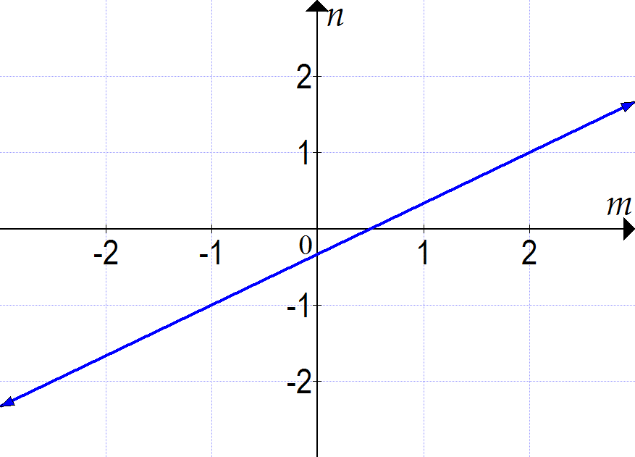

Question 13 4 marks [5.5]

*m* = 

= 

Substitute values into the rule and evaluate for each line segment.

*a*: (-2, -1), (2, 2) *b*: (1, -1), (2, 3) *c*: (1, -1), (-2, 2) *d*: (2, 0), (-1, 4)

|  |  |
| --- | --- |
| Line segment *a*:  *x*1 = -2, *x*2 = 2, *y*1 = -1, *y*2 = 2 | Line segment *b*:  *x*1 = 1, *x*2 = 2, *y*1 = -1, *y*2 = 3 |
| Line segment *c*:  *x*1 = 1, *x*2 = -2, *y*1 = -1, *y*2 = 2 | Line segment *d*:  *x*1 = 2, *x*2 = -1, *y*1 = 0, *y*2 = 4 |

(a) The line segment with the greatest *positive* gradient is *b. m* = 4

(b) The line segment with the greatest *negative* gradient is *d.* 

Question 14 3 marks [5.6]



Therefore *m* =  and *c* = 2.

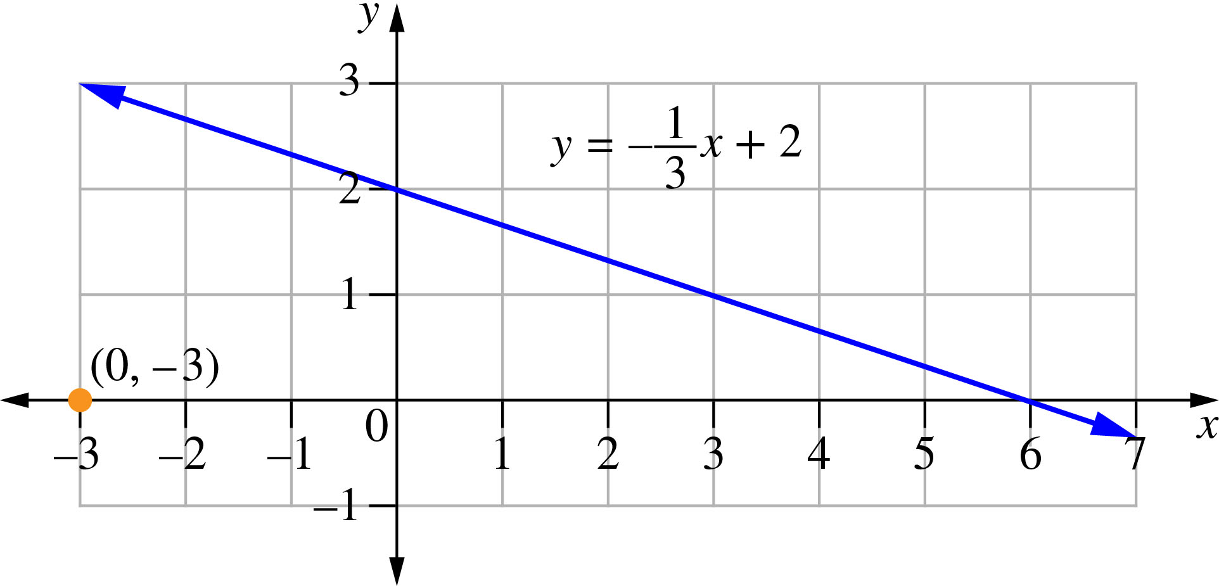

Question 15 3 marks [5.7]

Calculate the *x*-intercept by substituting *y* = 0 and solving the equation.

3*x* + 4*y* − 12 = 0

When *y* = 0:

3*x* + (4  0) − 12 = 0

3*x* = 12, *x* = 4

∴ *x*-intercept = (4, 0)

Calculate the *y*-intercept by substituting *x* = 0 and solving the equation.

3*x* + 4*y* − 12 = 0

When *x* = 0

0 + 4*y* − 12 = 0

4*y* = 12

*y* = 3

∴ *y*-intercept = (0, 3)

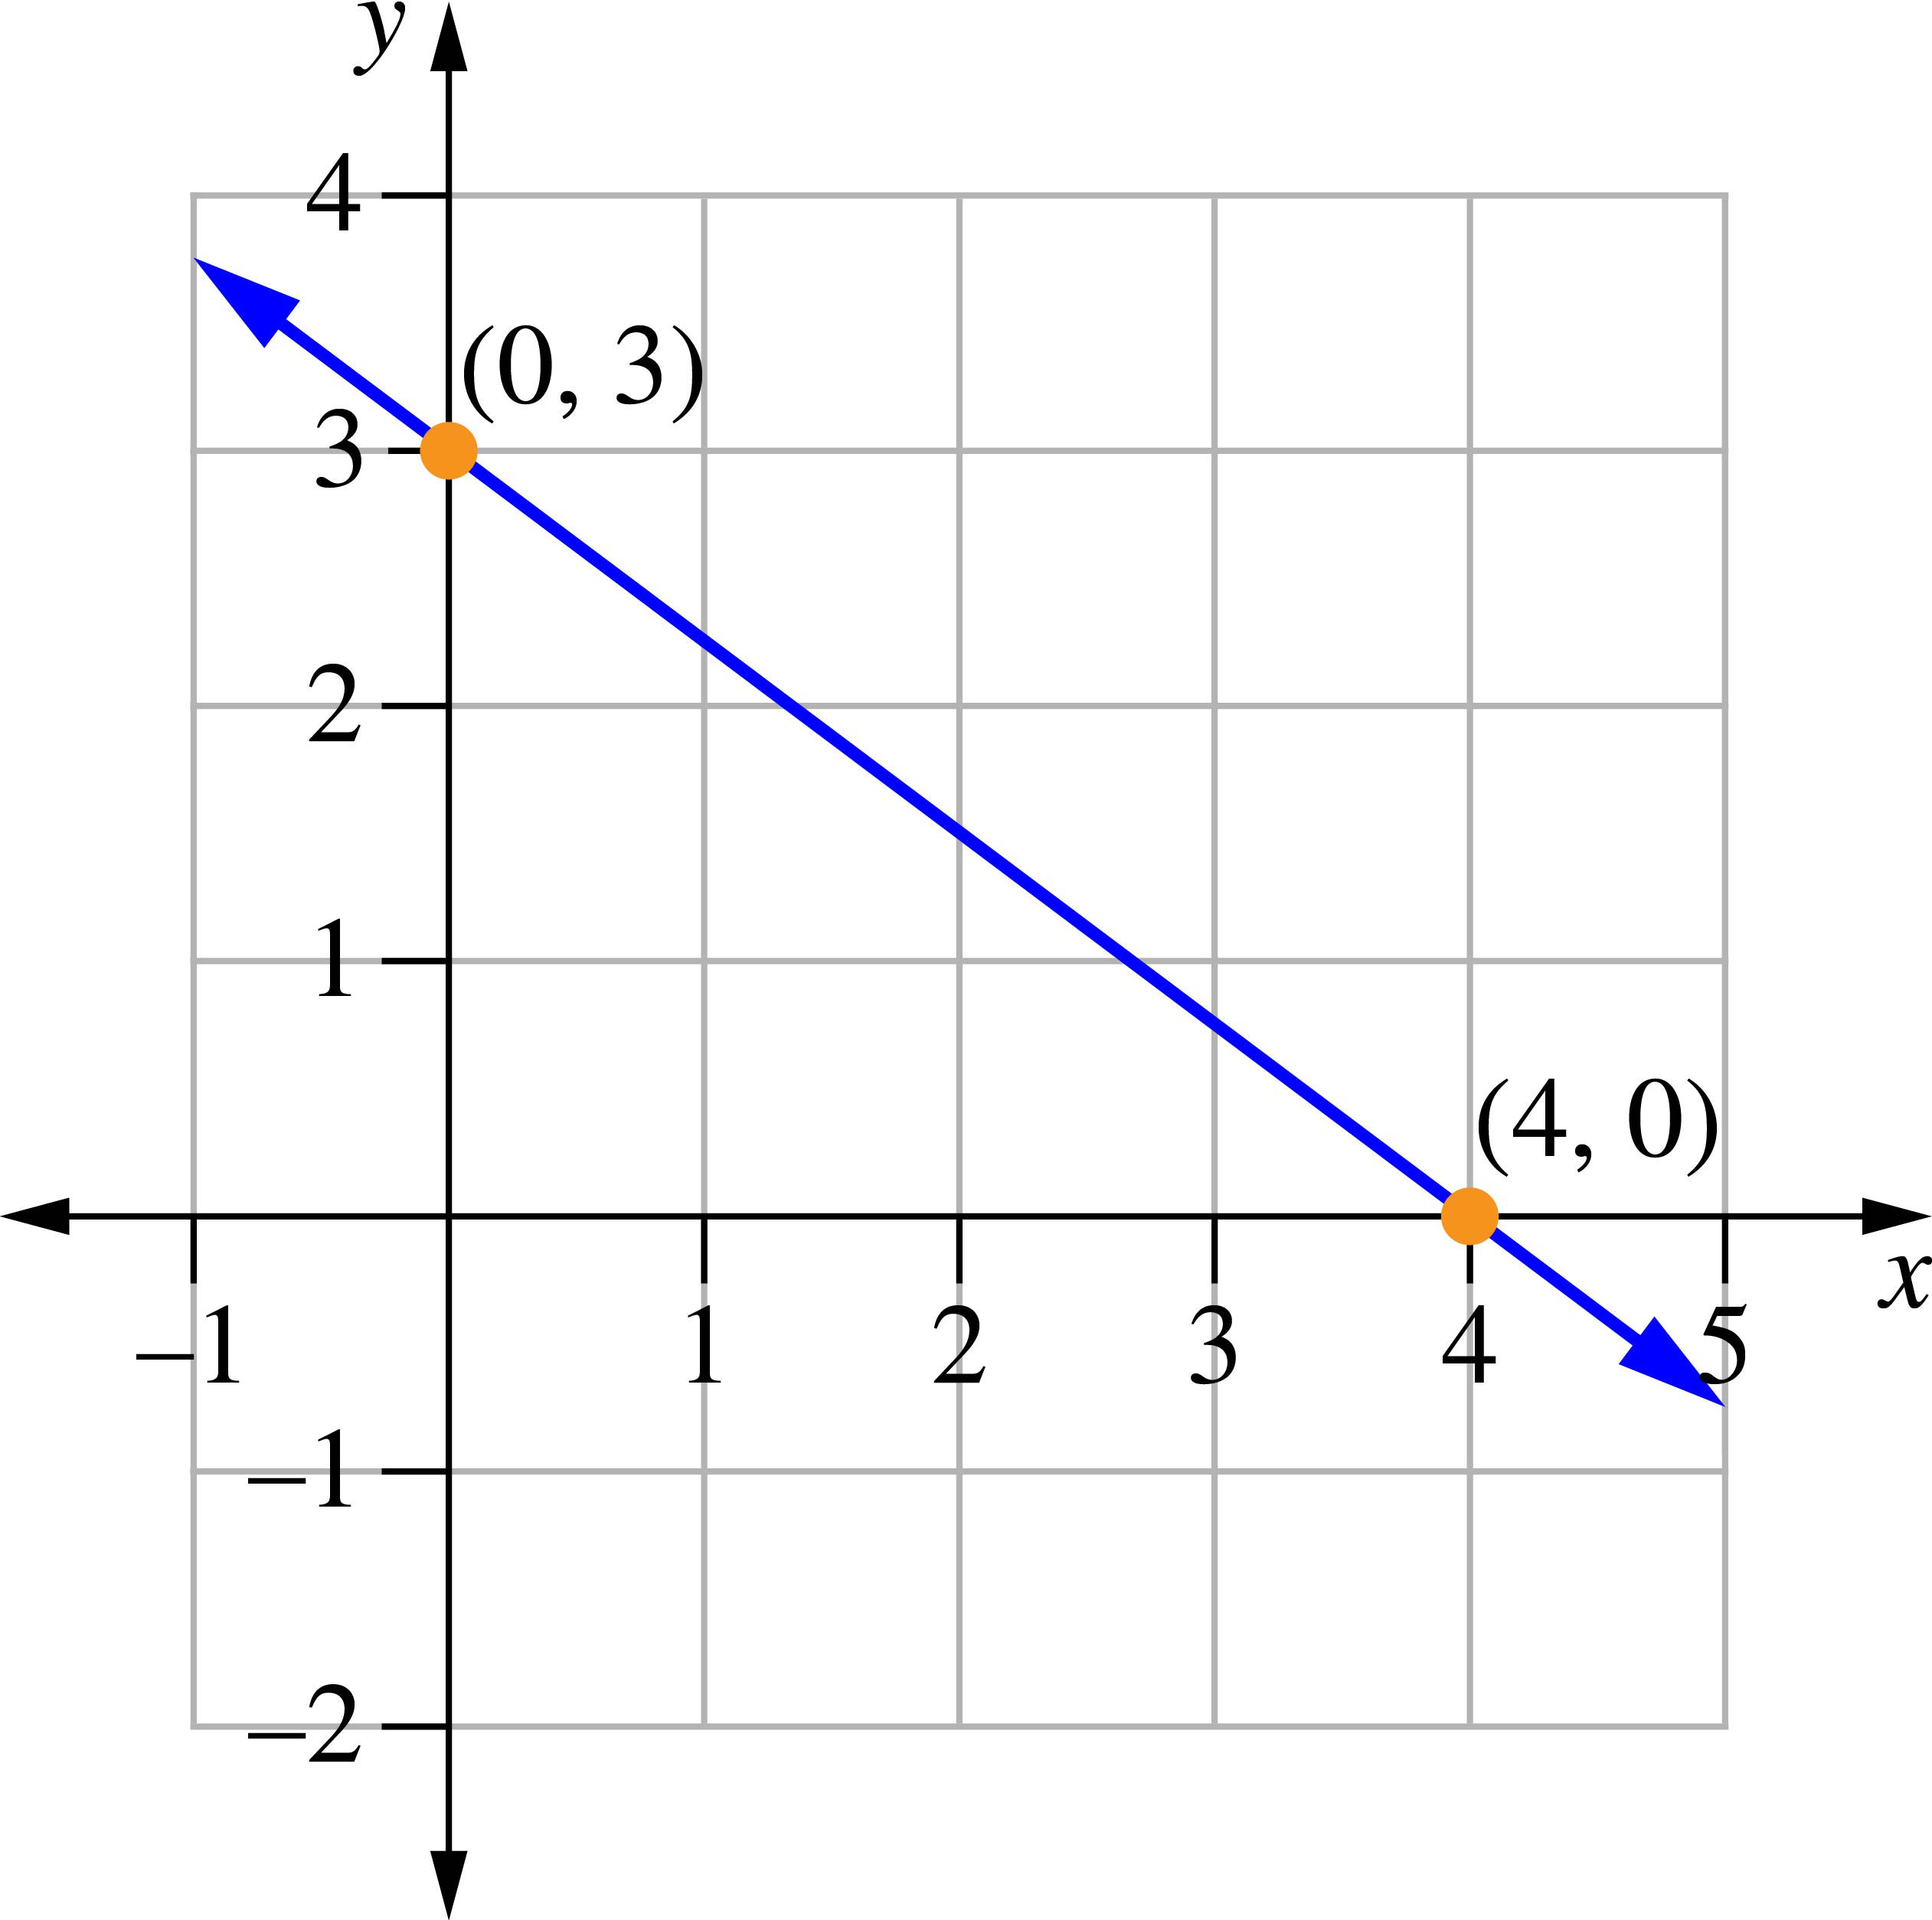

Question 16 2 marks [5.8]

(a) *y* = -3

(b) *x* = 4

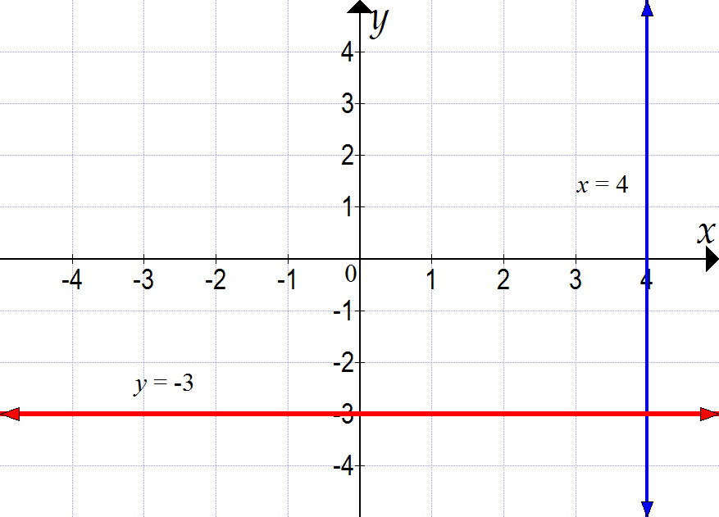

Short answer total marks: 27

Extended answer section

Question 17 5 marks [5.4, 5.5, 5.6, 5.7]

*y* = 4*x* + 7 is a linear equation in the form *y* = *mx* + *b*. The graph of the equation is a straight line, where *m* is the gradient and *b* is the *y*-intercept. To draw the graph, only two points are needed. Start at the *y*-intercept (0, 7) and use the gradient to find the next point. *m* = 4 means that rise = 4 and run = 1, so you should move up 4 and across 1 to find another point on the line: (11, 1).

Alternatively, the *x*-intercept can be found by substituting *y* = 0 into the equation:

4*x* + 7 = 0

4*x* = -7

*x* = , so *x*-intercept = (, 0). Use this and the *y*-intercept of (0, 7) to plot the graph.

Question 18 10 marks [5.2, 5.3]

(a) *AB*: 

*AD*: 

*CD*: 

*BC*: 

(b) *AC*: 

*BD*: 

(c) All sides are the same length but the two diagonals have different lengths. Therefore, the shape is a rhombus.

(d) midpoint *AC*:  = (6, 6)

midpoint *BD*:  = (6, 6)

**(e)** The midpoints of the diagonals coincide.

Question 19 10 marks [5.2, 5.3]

(a)

|  |  |  |  |  |  |  |  |  |  |
| --- | --- | --- | --- | --- | --- | --- | --- | --- | --- |
| Number of books/reader | 0 | 1 | 2 | 3 | 4 | 5 | 6 | 7 | 8 |
| Anthony | 0 | 2 | 4 | 6 | 8 | 10 | 12 | 14 | 16 |
| Belinda | 1 | 2.5 | 4 | 5.5 | 7 | 8.50 | 10 | 11.5 | 13 |
| Carlo | 10 | 10 | 10 | 10 | 10 | 10 | 10 | 10 | 10 |

(b)

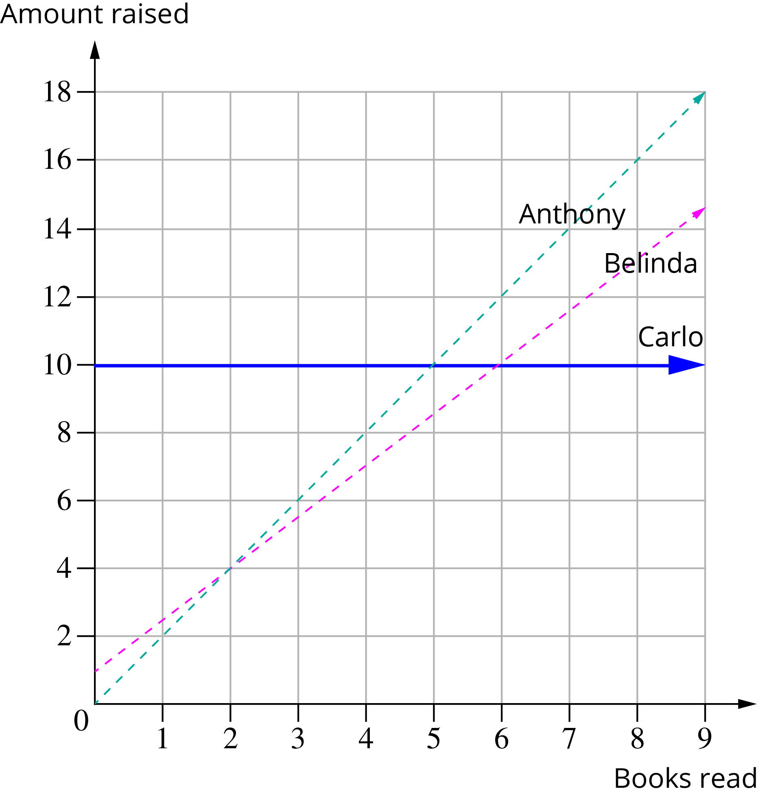

(c) No, they never collect the same amount, as there is no point at which all three lines intersect.

(d) (i) 6 or more books

(ii) never

(iii) 4 or fewer books

Extended answer total marks: 25

TOTAL test marks: 60